Creating the Deployment Package for Salt V3.x

- The Deployment package, which is in VSS has to be part of the same project in the VS IDE -
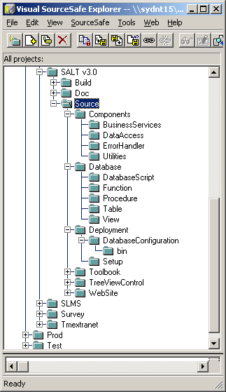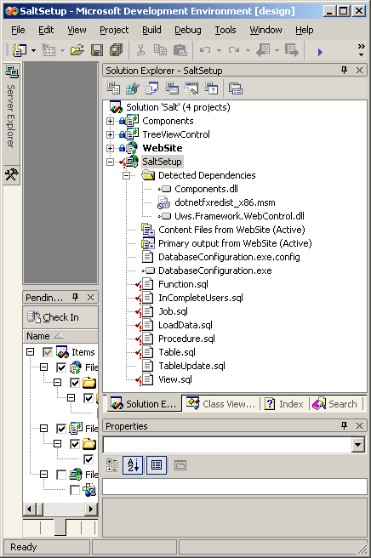

- Get latest version of all files in source safe:

- Edit the Deployment Files:

Firstly Edit DatabaseConfiguration.exe.config
Ensure that the Application Name value is up to date (check that the version is accurate):
‘<add key="ApplicationName" value="Salt 3.0" />’

Ensure that the default database name is correct:
‘<add key="DefaultDatabase" value="SaltTest" />’

Ensure that the NewVersionID is correct. This should match the Application name:
‘<add key="NewVersionID" value="Salt 3.0.3" />’

Ensure that the NewVersionType is accurate
<add key="NewVersionType" value="Upgrade" />

The script allows the ability to upgrade from a previous version of the database to this new version. The upgrade steps required for each version should be listed in the order that they must run in the migration settings area. The scripts to create an instance of the application in an empty database (new install) must be in a ‘CurrentVersion ID="-" section.’
The scripts for upgrades from other versions must be in a CurrentVersion area with an ID of the old version, eg:

<MigrationSettings>
<CurrentVersion ID="-">
<Step Description="Creating SQL server Job" Script="Job.sql"></Step>
<Step Description="Creating Tables" Script="Table.sql"></Step>
<Step Description="Creating Views" Script="View.sql"></Step>
<Step Description="Creating Functions" Script="Function.sql"></Step>
<Step Description="Creating Procedures" Script="Procedure.sql"></Step>
<Step Description="Load Data" Script="LoadData.sql"></Step>
</CurrentVersion>
<CurrentVersion ID="Salt 3.0">
<Step Description="Creating Procedures" Script="Procedure.sql"></Step>
</CurrentVersion>
<CurrentVersion ID="Salt 3.0.2">
<Step Description="Updating Tables" Script="TableUpdate.sql"></Step>
<Step Description="Creating Views" Script="View.sql"></Step>
<Step Description="Creating Functions" Script="Function.sql"></Step>
<Step Description="Creating Procedures" Script="Procedure.sql"></Step>
</CurrentVersion>
</MigrationSettings>

If it is an new install:

Create Tables should always be first.
The other steps should be in the following order:
Create Views
Create Functions
Create Procedures
Load Data
Create SQL Server Job

If it is an Update:
Update Tables should first
The other steps should be in the following order:
Create Views
Create Functions
Create Procedures
Load Data
Create SQL Server Job

Care should be taken when creating the script for the Create Functions step. If you script the functions in SQL Server Enterprise Manager the functions may not be created in the correct order. Usually the second last function udfReport_IncompleteUsers must be moved up the list so that it is the first function created as other functions are dependant on it and will not be created causing the entire update to fail.

Compiling the package:

Open the file system explorer in visual studio View > Editor > File System

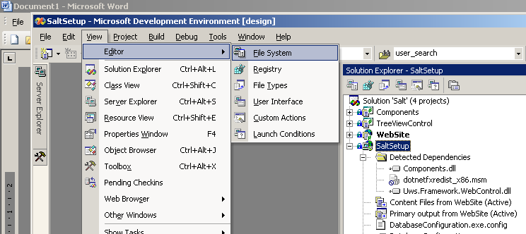

_If_ the source files are not under source control:

1) Delete the .sql and .config files in the file File System Pane
2) In the file system navigation pane navigate to File System on Target Machine > Program Files Folder > Salt
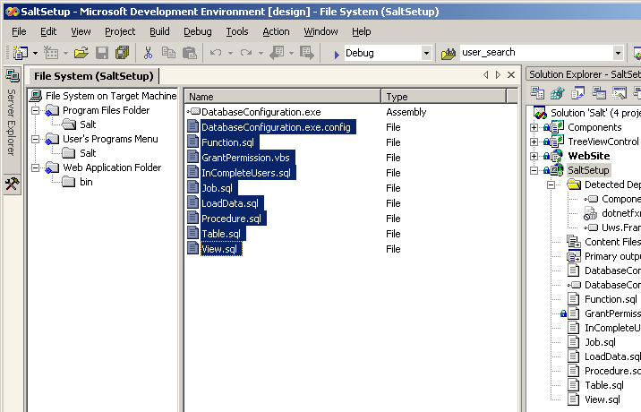
2) Open Salt
1) Delete .sql and .config files

- Add the edited files back into the project: (Right Click) “Salt” folder > Add > File

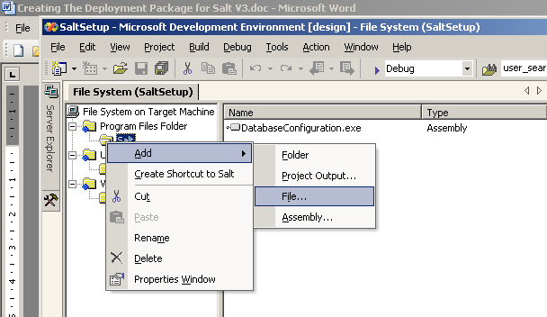
Select everything except the vss and databaseConfiguration.exe file
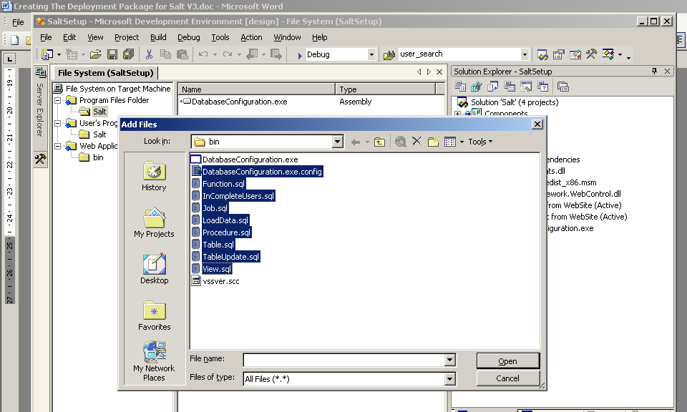

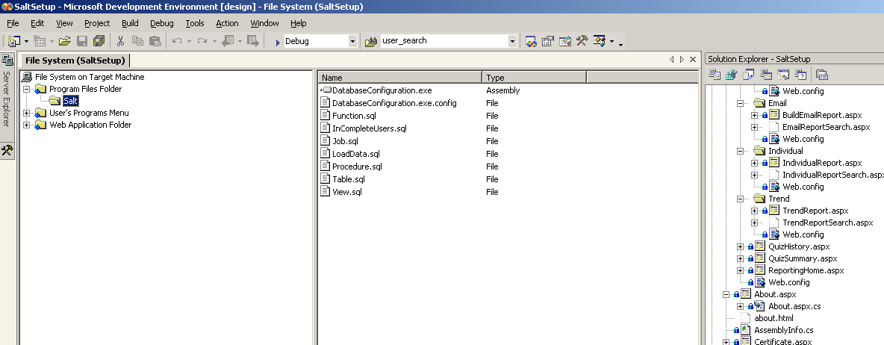

_If_ the files _are_ under source control they can be edited directly in the navigation pane.
(Right click) open
Edit the file
Save and check in.

Build the solution

That’s it, you are done.

The deployment files are in Source\Deployment\Setup\[Debug]|[Release]
There should be three files
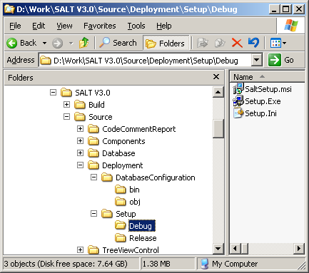

Copy the files from Source\Deployment\Setup\[Debug]|[Release] to the delivery medium.

Making changes and solving problems in the Deployment Package for Salt V3.x

If you edited the deployment package they you will need also need to delete and recreate the shortcut to the DatabaseConfiguration.exe in the User’s Program Menu > Salt folder.
To recreate the short cut: (right click) Create New Shortcut > Program Files Folder > Salt > (double click) DatabaseConfiguration.exe

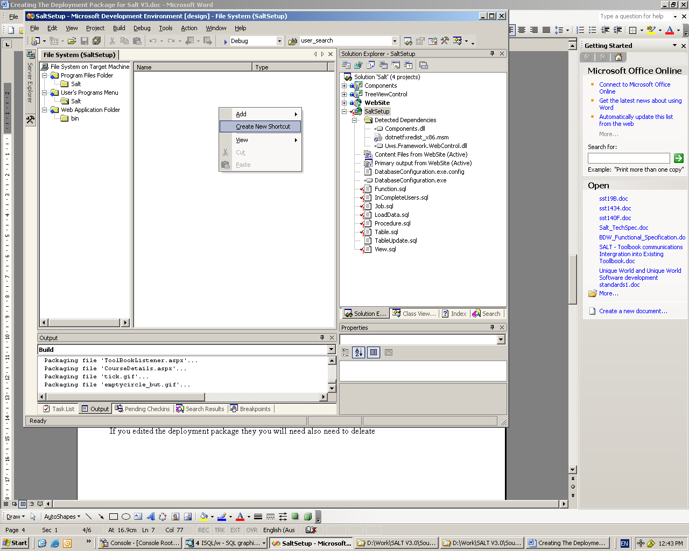

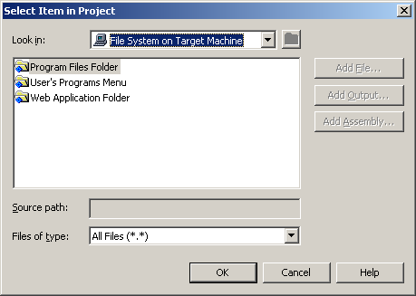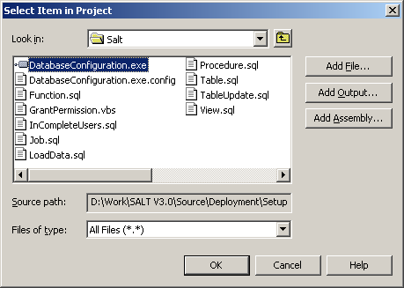

Rename the shortcut to “Salt - Database Selection”
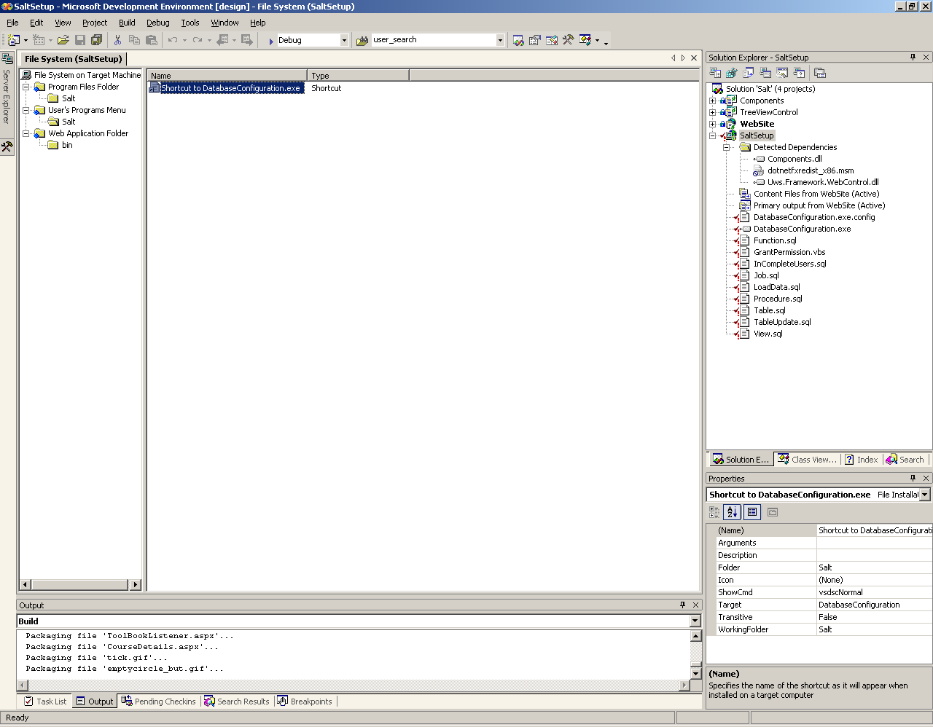

If something has broken or there has been a major change to the project. For example: a new components dll was added. It may be necessary to re-associate the new dll and with the deployment package.
This is done in the Web Application Folder of the File System navigation pane:
Open Web Application Folder > bin.
Select and delete the existing dll’s
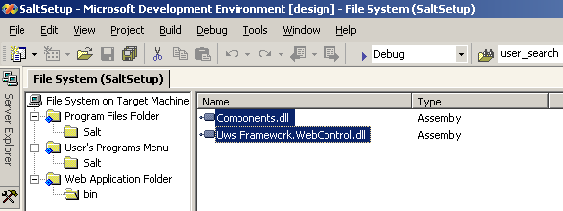

To add the dll’s back in, (right click) Add > Project Output > (select) Website from Project Dropdown > (select) “Primary Output” and “Content Files” > OK

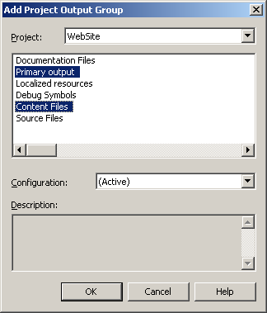

If you need to change the connection string or create another registry setting select the registry editor:
View > Editor > Registry
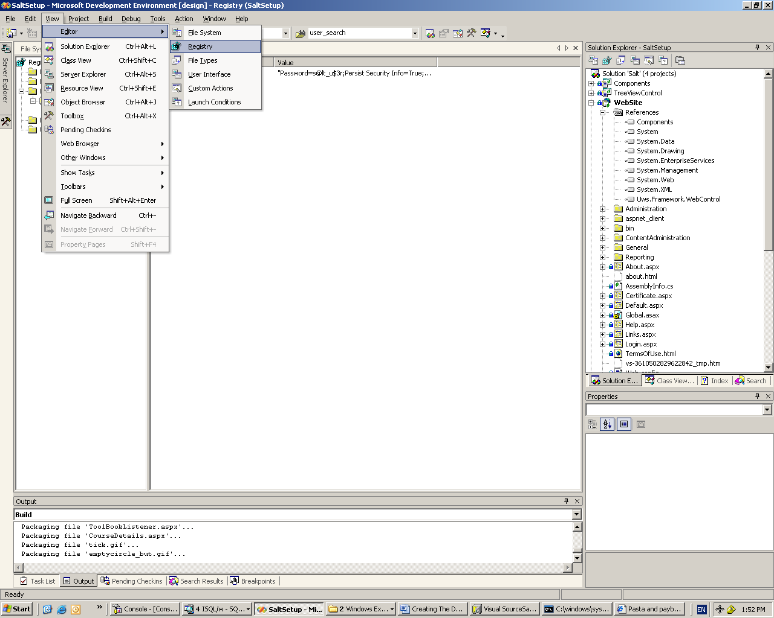

The Key should be called DatabaseConnection and lives in:
HKEY_LOCAL_MACHINE \ SOFTWARE \ Salt
New keys can be added by from the context menu
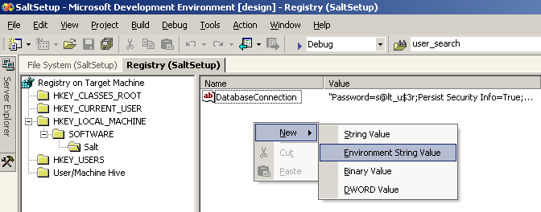

Custom actions:
Custom actions are scripts or other executables that are run by the deployment package. In this case the database deployment executable and the VBScript to grant write permission to three folders in the application are both custom actions.
More details are here: http://msdn.microsoft.com/library/en-us/vsintro7/html/vboriDeploymentInVisualStudio.asp?frame=true

The Grant Permission runs first.
If when the application is compiled it cannot find the GrantPermission.vbs file then you will have to reassociate it with the application. Open the Custom Actions editor:
View > Editor > Custom Actions
Browse to install

If the vbs is red squiggly underlined then delete it and add it again:
(right click on install node) > Add Custom Action > lookin: File System On Target Machine > Program Files Folder > Salt > (double click) GrantPermission.vbs

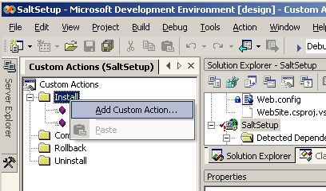
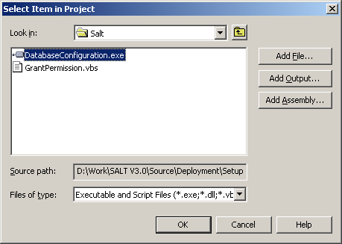

In the properties window ensure that the Custom Action Data has a value of: [TARGETDIR]|[WEBSITEUSERNAME]

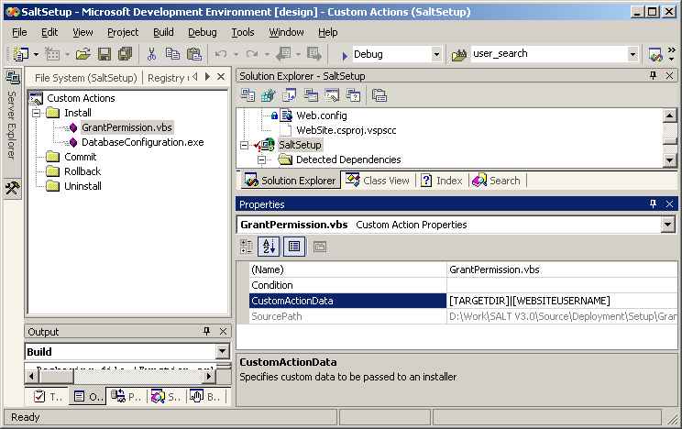

The process is exactly the same to add the DatabaseConfiguration.exe except that the is no Custom Action Data and the Installer Class must be set to false.

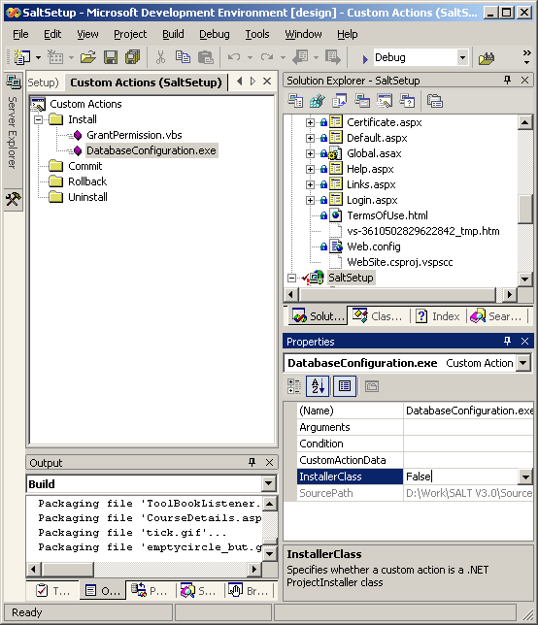

Scripting the Database Scripts
3.0.4
